ПАРТНЕРСКЕ ЗЕМЉЕ И ИНСТИТУЦИЈЕ НА ФП7, Х2020 и ХЕ
ПРОЈЕКТИМА ИНСТИТУТА ЗА ФИЗИКУ
У првих пет земаља партнера Инстутута за физику везано за учешће на ЕУ пројектима налазе се Италија, Немачка, Грчка, Шпанија и Холандија
Најзначајнија партнерска земља Института за физику на досадашњим реализованим ФП7, Х2020 и ХЕ пројектима је Италија са 23 партнерске институције и 32 реализована пројектна учешћа.
Назначајнија партнерска институција долази из Грчке (NATIONAL INFRASTRUCTURES FOR RESEARCH AND TECHNOLOGY) са учешћем на 10 заједничких пројеката, док је на другом месту С. Макединија (Ss. CYRIL AND METHODIUS UNIVERSITY IN SKOPJE) са учешћем на 7 заједничких пројеката. Ово је, иначе, једина македиснка партнерска институција Инатитуту на ЕУ пројектима.
Институт за физику је до сада имао сарадњу на ЕУ пројектима и са институцијама из Америке (УСА) и Азије (Јужна Кореја, Јапан, Кина, Индија итд), које будућим пројектним предлозима могу дати глобални карактер, што може бити и услов појединих позива.
Најзначајније земље партнери по броју партнерских институција
(са 10 и више инстиуција)
Italy | 23
Spain | 17
Germany | 17
Netherlands | 15
Greece | 13
France | 12
Belgium | 11
Hungary | 10
UK | 10
Најзначајније земље партнери по укупном броју учешћа на заједничким пројектима
(са 10 и више пројектних учешћа)
Italy | 32
Germany | 27
Greece | 24
Spain | 22
Netherlands | 22
France | 17
Hungary | 14
Switzerland | 14
Belgium | 13
UK | 12
Austria | 12
Bulgaria | 11
Најзначајније партнерске институције по броју учешћа на заједничким пројектима
(са 5 и више заједничких пројеката)
Greece | NATIONAL INFRASTRUCTURES FOR RESEARCH AND TECHNOLOGY | 10
N. Macedonia | Ss. CYRIL AND METHODIUS UNIVERSITY IN SKOPJE | 7
Finland | CSC-TIETEEN TIETOTEKNIIKAN KESKUS OY | 6
Austria | UNIVERSITAT LINZ | 6
Germany | KARLSRUHER INSTITUT FUER TECHNOLOGIE | 5
Moldova | RESEARCH AND EDUCATIONAL NETWORKING ASSOCIATION OF MOLDOVA | 5
Georgija | GEORGIAN RESEARCH AND EDUCATIONAL NETWORKING ASSOCIATION, Tbilisi | 5
Armenia | INSTITUTE FOR INFORMATICS AND AUTOMATION PROBLEMS OF THE NATIONAL ACADEMY OF SCIENCES OF THE REPUBLIC OF ARMENIA | 5
Norway | UNINETT SIGMA AS | 5
Turkey | TURKIYE BILIMSEL VE TEKNOLOJIK ARASTIRMA KURUMU, Ankara | 5
Montenegro | JAVNA USTANOVA UNIVERZITET CRNE GORE PODGORICA | 5
Институције интересантне за глобални карактер пројеката
Republic of Korea | KOREA INSTITUTE OF SCIENCE AND TECHNOLOGY INFORMATION  - 2 ФП7 пројекта (IPB SCL) | https://cordis.europa.eu/project/id/222667  https://cordis.europa.eu/project/id/261323
USA | THE BOARD OF REGENTS OF THE UNIVERSITY OF WISCONSIN SYSTEM  - 1 ФП7 пројект (IPB SCL) | https://cordis.europa.eu/project/id/222667
USA | THE UNIVERSITY OF NORTH CAROLINA AT CHAPEL HILL  - 1 ФП7 пројект (IPB SCL) | https://cordis.europa.eu/project/id/222667
Japan | INTER-UNIVERSITY RESEARCH INSTITUTE CORPORATION, HIGH ENERGY ACCELERATOR RESEARCH ORGANISATION  - 2 ФП7 пројекта (IPB SCL) | https://cordis.europa.eu/project/id/222667  https://cordis.europa.eu/project/id/261323
India | Indian Statistical Institute  - 1 ФП7 пројект (IPB SCL) | https://cordis.europa.eu/project/id/283770

Извор: https://ec.europa.eu/info/funding-tenders/opportunities/portal/screen/how-to-participate/org-details/999584904

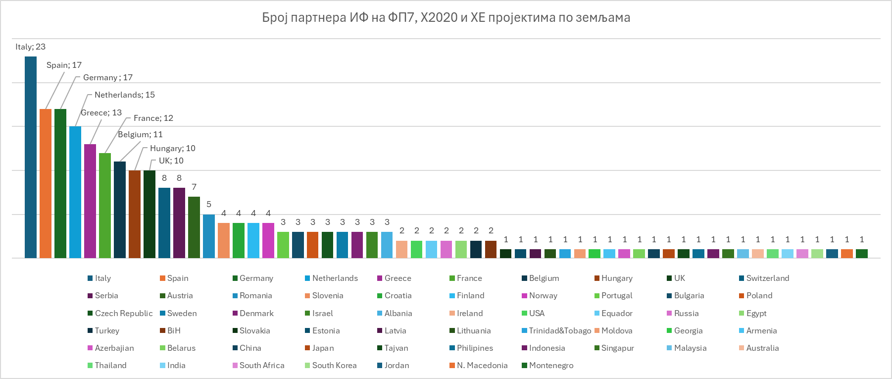

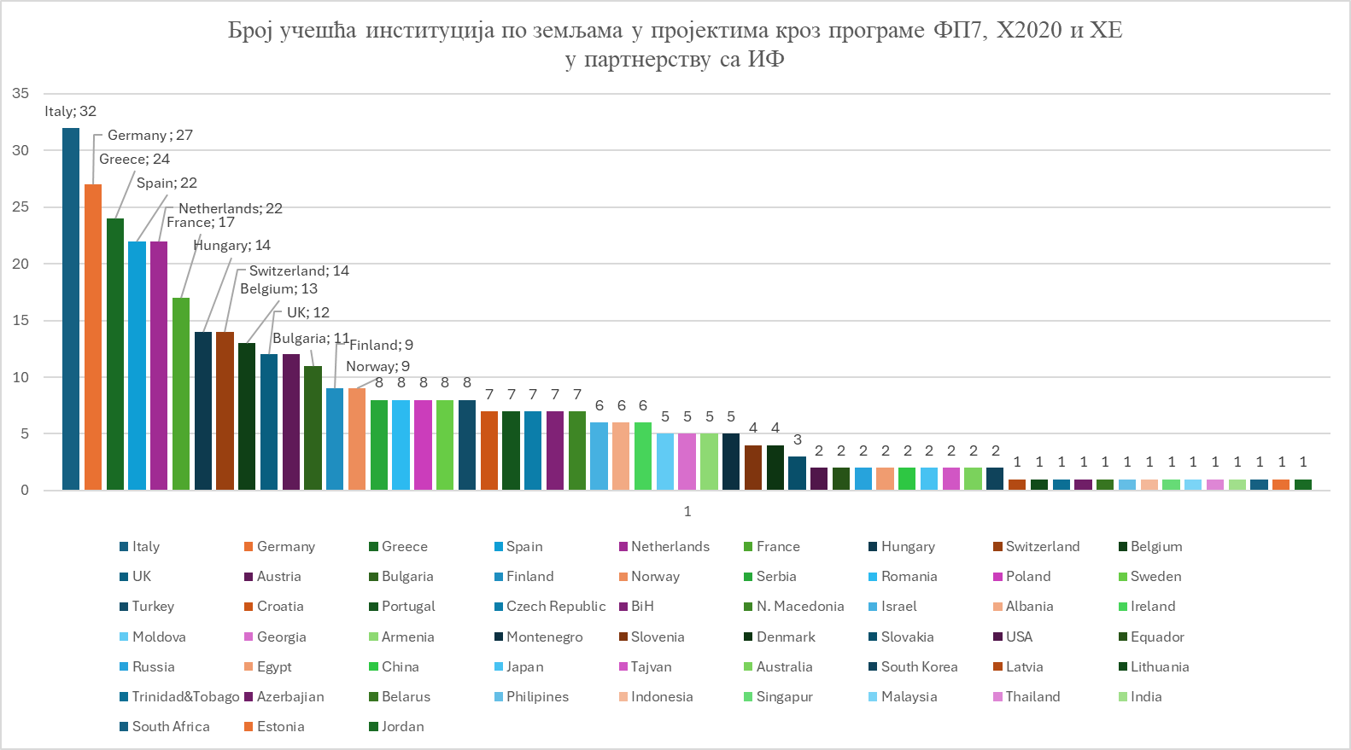

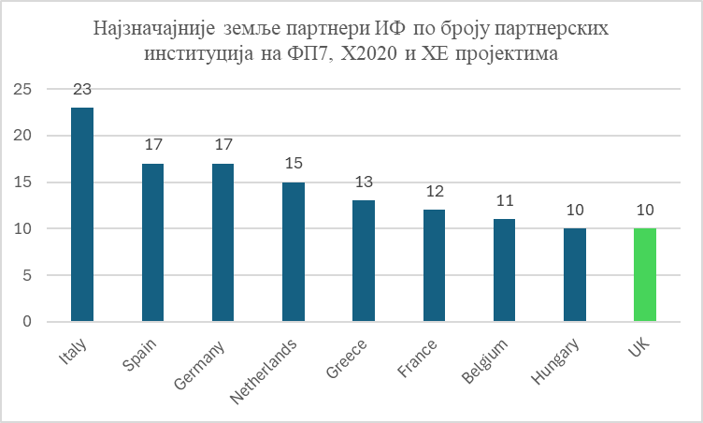
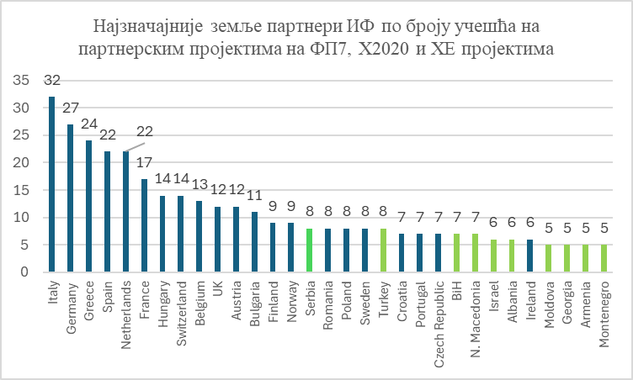
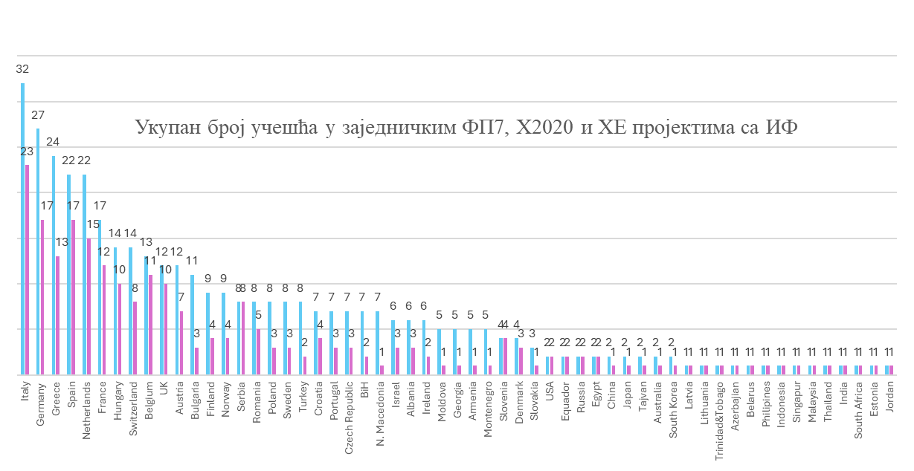

Земља | Назив институције | Број пројеката на којима је учествовала у партнерству са ИФ | Статус
Greece | NATIONAL INFRASTRUCTURES FOR RESEARCH AND TECHNOLOGY | 10 | Private for profit organisation
N. Macedonia | Ss. CYRIL AND METHODIUS UNIVERSITY IN SKOPJE | 7 | Research organization
Finland | CSC-TIETEEN TIETOTEKNIIKAN KESKUS OY | 6 | Other
Austria | UNIVERSITAT LINZ | 6 | Research organization
Germany | KARLSRUHER INSTITUT FUER TECHNOLOGIE | 5 | Research organization
Moldova | RESEARCH AND EDUCATIONAL NETWORKING ASSOCIATION OF MOLDOVA | 5 | Small or medium-size enterprise
Georgia | GEORGIAN RESEARCH AND EDUCATIONAL NETWORKING ASSOCIATION, Tbilisi | 5 | Research organization
Armenia | INSTITUTE FOR INFORMATICS AND AUTOMATION PROBLEMS OF THE NATIONAL ACADEMY OF SCIENCES OF THE REPUBLIC OF ARMENIA | 5 | Research organization
Norway | UNINETT SIGMA AS | 5 | Small or medium-size enterprise
Turkey | TURKIYE BILIMSEL VE TEKNOLOJIK ARASTIRMA KURUMU, Ankara | 5 | Research organization
Montenegro | JAVNA USTANOVA UNIVERZITET CRNE GORE PODGORICA | 5 | Research organization
Italy | CONSIGLIO NAZIONALE DELLE RICERCHE | 4 | Research organization
Italy | ISTITUTO NAZIONALE DI FISICA NUCLEARE | 4 | Research organization
France | CENTRE NATIONAL DE LA RECHERCHE SCIENTIFIQUE CNRS | 4 | Research organization
Croatia | SVEUCILISTE U ZAGREBU SVEUCILISNI RACUNSKI CENTAR | 4 | Research organization
Romania | INSTITUTUL NATIONAL DE CERCETARE-DEZVOLTARE IN INFORMATICA ICI BUCURESTI RA, Bucharest | 4 | Research organization
Bulgaria | INSTITUTE FOR PARALLEL PROCESSING OF THE BULGARIAN ACADEMY OF SCIENCES | 4 | Research organization
Bulgaria | INSTITUTE OF INFORMATION AND COMMUNICATION TECHNOLOGIES | 4 | Research organization
Poland | INSTYTUT CHEMII BIOORGANICZNEJ POLSKIEJ AKADEMII NAUK | 4 | Research organization
Sweden | VETENSKAPSRADET - SWEDISH RESEARCH COUNCIL | 4 | Research organization
Switzerland | ORGANISATION EUROPEENNE POUR LA RECHERCHE NUCLEAIRE, Geneva | 4 | International Organisation
Albania | UNIVERSITETI POLITEKNIK I TIRANES | 4 | Research organization
BiH | UNIVERZITET U BANJOJ LUCI | 4 | Research organization
Spain | AGENCIA ESTATAL CONSEJO SUPERIOR DE INVESTIGACIONES CIENTIFICAS | 3 | Research organization
Spain | BARCELONA SUPERCOMPUTING CENTER CENTRO NACIONAL DE SUPERCOMPUTACION | 3 | Research organization
Portugal | UNIVERSIDADE DE COIMBRA | 3 | Research organization
Portugal | LABORATORIO DE INSTRUMENTACAO E FISICA EXPERIMENTAL DE PARTICULAS LIP | 3 | Research organization
Italy | CINECA CONSORZIO INTERUNIVERSITARIO, Bologna | 3 | Research organization
France | GRAND EQUIPEMENT NATIONAL DE CALCUL INTENSIF | 3 | Other
Slovakia | USTAV INFORMATIKY SLOVENSKEJ AKADEMIE VIED, VEREJNA VYSKUMNA INSTITUCIA | 3 | Research organization
Bulgaria | ASSOCIATION "NATIONAL CENTRE FOR SUPERCOMPUTING APPLICATIONS, Sofia | 3 | Research organization
Poland | AKADEMIA GORNICZO-HUTNICZA IM. STANISLAWA STASZICA W KRAKOWIE | 3 | Research organization
Czech Republic | CESNET ZAJMOVE SDRUZENI PRAVNICKYCH OSOB, Prague | 3 | Research organization
Czech Republic | VSB - TECHNICAL UNIVERSITY OF OSTRAVA | 3 | Research organization
Sweden | UPPSALA UNIVERSITET | 3 | Research organization
Germany | Gauss Centre for Supercomputing (GCS) e.V. BERLIN | 3 | Research organization
Germany | FORSCHUNGSZENTRUM JULICH GMBH | 3 | Non-governmental organization
Ireland | THE PROVOST, FELLOWS, FOUNDATION SCHOLARS & THE OTHER MEMBERS OF BOARD, OF THE COLLEGE OF THE HOLY & UNDIVIDED TRINITY OF QUEEN ELIZABETH NEAR DUBLIN | 3 | Research organization
Ireland | UNIVERSITY OF GALWAY | 3 | Research organization
Belgium | KATHOLIEKE UNIVERSITEIT LEUVEN | 3 | Research organization
Netherlands | STICHTING NATIONALE COMPUTERFACILITEITEN | 3 | Research organization
Netherlands | STICHTING SURF | 3 | Other
Switzerland | EIDGENOESSISCHE TECHNISCHE HOCHSCHULE ZUERICH | 3 | Research organization
Israel | MACHBA - INTERUNIVERSITY COMPUTATION CENTER | 3 | Research organization
Turkey | ISTANBUL TEKNIK UNIVERSITESI | 3 | Research organization
BiH | UNIVERZITET U BANJOJ LUCI ELEKTROTEHNICKI FAKULTET | 3 | Research organization
Spain | UNIVERSIDAD DE ALCALA | 2 | Research organization
Italy | THE FOOD AND AGRICULTURE ORGANIZATION OF THE UNITED NATIONS, Roma | 2 | Public organization
Hungary | MTA KFKI RESZECSKE-ES MAGFIZIKAI KUTATOINTEZET, Budapest | 2 | Research organization
Hungary | SZAMITASTECHNIKAI ES AUTOMATIZALASI KUTATOINTEZET, Budapest | 2 | Research organization
Hungary | KORMANYZATI INFORMATIKAI FEJLESZTESI UGYNOKSEG, Budapest | 2 | Public organization
Hungary | NEMZETI INFORMACIOS INFRAST, RUKTURA FEJLESZTESI IRODA, Budapest | 2 | Public organization
Denmark | KOBENHAVNS UNIVERSITET | 2 | Research organization
Germany | FRIEDRICH-SCHILLER-UNIVERSITÄT JENA | 2 | Research organization
Germany | LEIBNIZ-INSTITUT FUR ANALYTISCHE WISSENSCHAFTEN-ISAS-EV | 2 | Research organization
Greece | MANOUSELILS N. STOITSIS G. AND SIAOE | 2 | Small or medium-size enterprise
Greece | ATHINA-EREVNITIKO KENTRO KAINOTOMIAS STIS TECHNOLOGIES TIS PLIROFORIAS, TON EPIKOINONION KAI TIS GNOSIS | 2 | Research organization
Netherlands | STICHTING EGI, Amsterdam | 2 | Other
Netherlands | TECHNISCHE UNIVERSITEIT DELFT | 2
Netherlands | SURF BV | 2 | Private for profit organisation
Switzerland | SWITCH, Bern | 2 | Small or medium-size enterprise
Norway | SIGMA2 AS | 2 | Research organization
China | AGRICULTURAL INFORMATION INSTITUTE OF CHINESE ACADEMY OF AGRICULTURAL SCIENCES, Beijing | 2 | Research organization
Japan | INTER-UNIVERSITY RESEARCH INSTITUTE CORPORATION, HIGH ENERGY ACCELERATOR RESEARCH ORGANISATION | 2 | Research organization
Tajvan | ACADEMIA SINICA, Taipei City | 2 | Research organization
Australia | UNIVERSITY OF MELBOURNE | 2 | Research organization
Israel | TEL AVIV UNIVERSITY | 2 | Research organization
UK | THE UNIVERSITY OF EDINBURGH | 2 | Research organization
UK | SCIENCE AND TECHNOLOGY FACILITIES COUNCIL, Oxford | 2 | Research organization
Spain | UNIVERSIDAD DE SANTIAGO DE COMPOSTELA | 1 | Research organization
Spain | UNIVERSIDAD DE VIGO | 1 | Research organization
Spain | INNOGESTIONA AMBIENTAL SL | 1 | Small or medium-size enterprise
Spain | GABINETE DE GESTION INTEGRAL DE RECURSOS SL | 1 | Small or medium-size enterprise
Spain | SPACE RESEARCH AND TECHNOLOGY INSTITUTE | 1 | Research organization
Spain | FUNDACION CITOLIVA, CENTRO DE INNOVACION Y TECNOLOGIA DEL OLIVAR Y DEL ACEITE | 1 | Research organization
Spain | UNIVERSIDAD CARLOS III DE MADRID | 1 | Research organization
Spain | FUNDACION LANTEGI BATUAK | 1 | Other
Spain | FUNDACION AZTI - AZTI FUNDAZIOA | 1 | Other
Spain | LA TRUFA DE ALAVA - ARABAKO BOILURRA KOOP E | 1 | Small or medium-size enterprise
Spain | FUNDACIO INSTITUT CATALA DE RECERCA DE L'AIGUA | 1 | Research organization
Spain | INSTITUTO DE FISICA DE ALTAS ENERGIAS | 1 | Research organization
Spain | FUNDACIO INSTITUT CATALA DE NANOCIENCIA I NANOTECNOLOGIA | 1 | Research organization
Spain | E-SCIENCE EUROPEAN INFRASTRUCTURE FOR BIODIVERSITY AND ECOSYSTEM RESEARCH | 1 | Research organization
Portugal | FACULDADE CIENCIAS E TECNOLOGIA DA UNIVERSIDADE DE COIMBRA | 1 | Research organization
Italy | UNIVERSITA DEGLI STUDI DI CAGLIARI, Sardinia | 1 | Research organization
Italy | UNIVERSITA DEGLI STUDI DI TORINO | 1 | Research organization
Italy | UNIVERSITA DEGLI STUDI DEL PIEMONTE ORIENTALE AMEDEO AVOGADRO | 1 | Research organization
Italy | CENTRO INTERNAZIONALE IN MONITORAGGIO AMBIENTALE - FONDAZIONE CIMA, Savona | 1 | Research organization
Italy | ELSAG DATAMAT S.P.A. | 1 | Private for profit organisation
Italy | UNIVERSITA DEGLI STUDI DI TRENTO | 1 | Research organization
Italy | ALCE NERO SPA | 1 | Private or profit organization
Italy | UNIVERSITA DEGLI STUDI DI FERRARA | 1 | Research organization
Italy | ALMA MATER STUDIORUM - UNIVERSITA DI BOLOGNA | 1 | Research organization
Italy | ARVAIA SOCIETA COOPERATIVA AGRICOLA | 1 | Private for profit organisation
Italy | CENTRO INTERNAZIONALE DI ALTISTUDI AGRONOMICI MEDITERRANEI, Bari | 1 | International Organisation
Italy | LEGA REGIONALE DELLE COOPERATIVE E MUTUE | 1 | Non-governmental organization
Italy | FONDAZIONE CENTRO EURO-MEDITERRANEOSUI CAMBIAMENTI CLIMATICI, Lecce | 1 | Research organization
Italy | AGENZIA NAZIONALE PER LE NUOVE TECNOLOGIE, L'ENERGIA E LO SVILUPPO ECONOMICO SOSTENIBILE, Roma | 1 | Research organization
Italy | CONSORTIUM GARR, Roma | 1 | Research organization
Italy | EUROPEAN PLATE OBSERVING SYSTEM - EUROPEAN RESEARCH INFRASTRUCTURE CONSORTIUM, Roma | 1 | Research organization
Italy | MINISTERO DELLE IMPRESE E DEL MADE IN ITALY, Roma | 1 | Research organization
Italy | CONFEDERAZIONE GENERALE DELL AGRICOLTURA ITALIANA, Roma | 1 | Other
Italy | UNIVERSITA DEGLI STUDI DI ROMA TOR VERGATA | 1 | Research organization
France | BT INFRASTRUCTURES CRITIQUES SAS | 1 | Private for profit organisation
France | HORIBA FRANCE SAS | 1 | Private for profit organisation
France | CGG SERVICES SAS | 1 | Private for profit organisation
France | ASSOCIATION DE COORDINATION TECHNIQUE POUR L'INDUSTRIE AGROALIMENTAIRE | 1 | Other
France | CENTRE TECHNIQUE DE LA CONSERVATION DES PRODUITS AGRICOLES | 1 | Small or medium-size enterprise
France | BT Services SA | 1 | Private for profit organisation
France | ASSOCIATION EUROPEENNE EURISY | 1 | Non-governmental organization
France | A LA FERME | 1 | Private for profit organisation
France | UNIVERSITE D'AIX MARSEILLE | 1 | Research organization
France | ECOLE CENTRALE DE MARSEILLE EGIM | 1 | Research organization
Slovenia | UNIVERZA V MARIBORU UNIVERZITETNA KNJIZNICA MARIBOR | 1 | Research organization
Slovenia | UNIVERZA V LJUBLJANI | 1 | Research organization
Slovenia | INSTITUT JOZEF STEFAN, Ljubljana | 1 | Research organization
Slovenia | AKADEMSKA IN RAZISKOVALNA MREZA SLOVENIJE | 1 | Public organization
Croatia | SVEUCILISTE U ZAGREBU FAKULTET KEMIJSKOG INZENJERSTVA I TEHNOLOGIJE, Zagreb | 1 | Research organization
Croatia | SVEUCILISTE U ZAGREBU, FAKULTET STROJARSTVA I BRODOGRADNJE | 1 | Research organization
Croatia | SVEUCILISTE U ZAGREBU FAKULTET KEMIJSKOG INZENJERSTVA I TEHNOLOGIJE | 1 | Research organization
Hungary | ZALA TERMALVOLGYE EGYESULET | 1 | Non-governmental organization
Hungary | KISLEPTEKU TERMEKELOALLITOK ES SZOLGALTATOK ORSZAGOS ERDEKKEPVISELETENEK EGYESULETE | 1 | Non-governmental organization
Hungary | DEBRECENI EGYETEM | 1 | Research organization
Hungary | FOODHUB.HU TERMELOI AGRAR SZOLGALTATO NONPROFIT ZARKORUEN MUKODO RESZVENYTARSASAG, Budapest | 1 | Non-governmental organization
Hungary | WIGNER FIZIKAI KUTATOKOZPONT, Budapest | 1 | Research organization
Hungary | CAMPDEN BRI MAGYARORSZAG NONPROFITKFT, Budapest | 1 | Research organization
Romania | UNIVERSITATEA DE VEST DIN TIMISOARA | 1 | Research organization
Romania | UNITATEA EXECUTIVA PENTRU FINANTAREA INVATAMANTULUI SUPERIOR A CERCETARII DEZVOLTARII SI INOVARII, Bucharest | 1 | Research organization
Romania | INSTITUTUL NATIONAL DE CERCETARE-DEZVOLTARE PENTRU FIZICA SI INGINERIE NUCLEARA-HORIA HULUBEI, Bucharest | 1 | Research organization
Romania | INSTITUTUL NATIONAL DE CERCETARE DEZVOLTARE PENTRU OPTOELECTRONICA INOE 2000, Bucharest | 1 | Research organization
Estonia | TARTU ULIKOOL, Tartu | 1 | Research organization
Latvia | LATVIJAS UNIVERSITATES MATEMATIKAS UN INFORMATIKAS INSTITUTS, Riga | 1 | Research organization
Lithuania | VILNIAUS UNIVERSITETAS | 1 | Research organization
Poland | PREMOTEC POLAND SP. Z O.O. | 1 | Small or medium-size enterprise
Czech Republic | Masarykova univerzita | 1 | Research organization
Finland | TAMPEREEN KORKEAKOULUSAATIO SR | 1 | Research organization
Finland | HELSINGIN YLIOPISTO | 1 | Research organization
Finland | EUDAT OY | 1 | Other
Sweden | GOETEBORGS UNIVERSITET | 1 | Research organization
Denmark | NORDUNET A/S | 1 | Small or medium-size enterprise
Denmark | DANMARKS TEKNISKE UNIVERSITET | 1 | Research organization
Germany | JENOPTIK POLYMER SYSTEMS GMBH | 1 | Private for profit organisation
Germany | MICRO RESIST TECHNOLOGY GESELLSCHAFT FUER CHEMISCHE MATERIALIEN SPEZIELLER PHOTORESISTSYSTEME MBH, BERLIN | 1 | Small or medium-size enterprise
Germany | SENTECH INSTRUMENTS GMBH, BERLIN | 1 | Small or medium-size enterprise
Germany | SOLIDARISCHE LANDWIRTSCHAFT EV | 1 | Non-governmental organization
Germany | DEUTSCHES ELEKTRONEN-SYNCHROTRON DESY | 1 | Research organization
Germany | LANDWIRTSCHAFTSKAMMER NIEDERSACHSEN | 1 | Public organization
Germany | RHEINISCH-WESTFAELISCHE TECHNISCHE HOCHSCHULE AACHEN | 1 | Research organization
Germany | EUROPEAN MOLECULAR BIOLOGY LABORATORY | 1 | Research organization
Germany | UNIVERSITAET HOHENHEIM | 1 | Research organization
Germany | FORSCHUNGSZENTRUM KARLSRUHE GMBH | 1 | Research organization
Germany | UNIVERSITAET REGENSBURG | 1 | Research organization
Germany | EUROPEAN MOLECULAR BIOLOGY LABORATORY | 1 | Research organization
Austria | SALZBURG RESEARCH FORSCHUNGSGESELLSCHAFT M.B.H | 1 | Research organization
Austria | NATURHISTORISCHES MUSEUM | 1 | Research organization
Austria | TECHNISCHE UNIVERSITAET WIEN | 1 | Research organization
Austria | ISEKI-FOOD - EUROPAISCHE GESELLSCHAFT FUR DIE INTEGRATION DER LEBENSMITTELWISSINSCHAFT UND -TECHNOLGIE IN DIE LEBENSMITTELVERSORGUNGSKETTE | 1 | Small or medium-size enterprise
Austria | SEMANTIC WEB COMPANY GMBH | 1 | Small or medium-size enterprise
Austria | PROFACTOR GMBH | 1 | Non-governmental organization
Greece | PANEPISTIMIO KRITIS | 1 | Research organization
Greece | NATIONAL CENTER FOR SCIENTIFIC RESEARCH "DEMOKRITOS" | 1 | Research organization
Greece | ASTIKOS PROMITHEUTIKOS SYNETAIRISMOS PERIORISMENIS EUTHYNIS ALLOTROPON | 1 | Private for profit organisation
Greece | DIABALKANIKO KENTRO PERIBALLONTOS | 1 | Other
Greece | ETHNIKO ASTEROSKOPEIO ATHINON | 1 | Research organization
Greece | IDRYMA IATROVIOLOGIKON EREUNON AKADEMIAS ATHINON | 1 | Research organization
Greece | OPENAIRE MAKE | 1 | Non-governmental organization
Greece | SINETERISMOS PARAGOGON - KATANALOTON OIKOLOGIKON PROIONTON GAIA PE | 1 | Private for profit organisation
Greece | IDRYMA TECHNOLOGIAS KAI EREVNAS | 1 | Research organization
Belgium | UNIVERSITE DE NAMUR ASBL | 1 | Research organization
Belgium | VRIJE UNIVERSITEIT BRUSSEL | 1 | Research organization
Belgium | FOODDRINKEUROPE AISBL | 1 | Research organization
Belgium | PARTNERSHIP FOR ADVANCED COMPUTING IN EUROPE AISBL | 1 | Research organization
Belgium | COMITE DES ORGANISATIONS PROFESSIONNELLES AGRICOLE DE L UNION EUROPEENNE COPA ASSOCIATION DE FAIT | 1 | Non-governmental organizatio
Belgium | OPEN ACCESS IN THE EUROPEAN AREA THROUGH SCHOLARLY COMMUNICATION | 1 | Research organization
Belgium | EuroGeoSurveys - EGS | 1 | Other
Belgium | FRUITVEGETABLES EUROPE | 1 | Small or medium-size enterprise
Belgium | EUROPEAN FOOD INFORMATION COUNCIL | 1 | Research organization
Belgium | EUROPEAN ASSOCIATION OF REMOTE SENSING COMPANIES | 1 | Other
Netherlands | NATUURLIJK VLEESPAKKET BV | 1 | Small or medium-size enterprise
Netherlands | BRANDT & LEVIE BV, Amsterdam | 1 | Small or medium-size enterprise
Netherlands | STICHTING ACADEMISCH REKENCENTRUM AMSTERDAM (SARA). | 1 | Small or medium-size enterprise
Netherlands | NEDERLANDSE ORGANISATIE VOOR WETENSCHAPPELIJK ONDERZOEK | 1 | Research organization
Netherlands | STICHTING NEDERLANDS BAKKERIJ CENTRUM | 1 | Small or medium-size enterprise
Netherlands | WAGENINGEN UNIVERSITY | 1 | Research organization
Netherlands | STICHTING WAGENINGEN RESEARCH | 1 | Research organization
Netherlands | AMPED CONCEPTS BV | 1 | Small or medium-size enterprise
Netherlands | STICHTING NEDERLANDSE WETENSCHAPPELIJK ONDERZOEK INSTITUTEN | 1 | Research organization
Netherlands | UNIVERSITEIT UTRECHT | 1 | Research organization
USA | THE BOARD OF REGENTS OF THE UNIVERSITY OF WISCONSIN SYSTEM | 1 | Research organization
USA | THE UNIVERSITY OF NORTH CAROLINA AT CHAPEL HILL | 1 | Research organization
Trinidad&Tobago | UNIVERSITAT POLITECNICA DE VALENCIA | 1 | Research organization
Equador | CENTRO DE TRANSFERENCIA DE TECNOLOGIAS ESCUELA SUPERIOR POLITECNICA DEL LITORAL | 1 | Research organization
Equador | EMPRESA PUBLICA DE SERVICIOS ESPOL - TECH EP | 1 | Research organization
Switzerland | JEAN-MICHEL BESSON | 1 | Other
Switzerland | BIOFRUITS SA | 1 | Small or medium-size enterprise
Switzerland | ECOLE POLYTECHNIQUE FEDERALE DE LAUSANNE | 1 | Research organization
Switzerland | EIDGENOESSISCHES DEPARTEMENT FUER WIRTSCHAFT, BILDUNG UND FORSCHUNG, Bern | 1 | Public organization
Switzerland | SCHWEIZERISCHES FORSCHUNGSINSTITUT FUER HOCHGEBIRGSKLIMA UND MEDIZIN IN DAVOS | 1 | Non-governmental organization
Azerbajian | AZERBAIJAN RESEARCH AND EDUCATIONAL NETWORKS ASSOCIATION, Baku | 1 | Research organization
Belarus | UNITED INSTITUTE OF INFORMATICS PROBLEMS OF NATIONAL ACADEMY OF SCIENCES OF BELARUS | 1 | Research organization
Norway | CESSDA ERIC, Bergen | 1 | Research organization
Norway | DIREKTORATET FOR HOYERE UTDANNING OG KOMPETANSE, Bergen | 1 | Research organization
Russia | JOINT INSTITUTE FOR NUCLEAR RESEARCH | 1 | Research organization
Russia | RUSSIAN RESEARCH CENTRE KURCHATOV INSTITUTE | 1 | Research organization
Philipines | ADVANCED SCIENCE AND TECHNOLOGY INSTITUTE, Manila | 1 | Research organization
Indonesia | INSTITUT TEKNOLOGI BANDUNG, Jakarta | 1 | Research organization
Singapur | NATIONAL UNIVERSITY OF SINGAPORE PUBLIC COMPANY LIMITED BY GUARANTEE | 1 | Research organization
Malaysia | UNIVERSITI PUTRA MALAYSIA, Kuala Lumpur | 1 | Research organization
Thailand | NATIONAL SCIENCE & TECHNOLOGY DEVELOPMENT AGENCY | 1 | Research organization
India | Indian Statistical Institute | 1 | Research organization
South Africa | CHONNAM NATIONAL UNIVERSITY | 1 | Research organization
SouthKorea | KOREA INSTITUTE OF SCIENCE AND TECHNOLOGY INFORMATION  https://cordis.europa.eu/project/id/222667  https://cordis.europa.eu/project/id/261323 | 1 | Research organization
Egypt | CENTRE FOR ENVIRONMENT AND DEVELOPMENT FOR THE ARAB REGION AND EUROPE, Kairo | 1 | Research organization
Egypt | BIBLIOTHECA ALEXANDRINA*LIBRARY OFALEXANDRIA BIBALEX | 1 | Research organization
Israel | THE HEBREW UNIVERSITY OF JERUSALEM | 1 | Research organization
Jordan | SYNCHROTRON-LIGHT FOR EXPERIMENTAL SCIENCE AND APPLICATIONS IN THE MIDDLE EAST | 1 | Research organization
Albania | QENDREN NDERINSTITUCIONALE TE RRJETI AKADEMIK SHQIPTAR | 1 | Research organization
Albania | INSTITUTI PER RUAJTJEN E NATYRES SHQIPTARE SHOQATA | 1 | Research organization
Serbia | INOSENS DOO NOVI SAD | 1 | Research organization
Serbia | PROMETNO DRUSTVO SA OGRANICENOM ODGOVORNOSCU POLO CACAK | 1 | Private for profit organisation
Serbia | UDRUZENJE KOMPANIJA ZA PRERADU VOCA I POVRCA KRALJEVO | 1 | Other
Serbia | UNIVERZITET U BEOGRADU | 1 | Research organization
Serbia | SENZOR INFIZ DOO | 1 | Private for profit organisation
Serbia | FACULTY OF TECHNOLOGY AND METALLURGY UNIVERSITY OF BELGRADE | 1 | Research organization
Serbia | FACULTY OF AGRICULTURE - UNIVERSITY OF BELGRADE | 1 | Research organization
Serbia | FACULTY OF BIOLOGY OF THE UNIVERSITY OF BELGRADE | 1 | Research organization
UK | INSTITUTE OF NANOTECHNOLOGY, Glasgow | 1 | Research organization
UK | GEANT LIMITED, Cambridge | 1 | Small or medium-size enterprise
UK | TRUST-IT SERVICES LIMITED, London | 1 | Small or medium-size enterprise
UK | 21C CONSULTANCY LIMITED, London | 1 | Small or medium-size enterprise
UK | NUWAVE SYSTEM LTD, London | 1 | Small or medium-size enterprise
UK | INSTRUCT-ERIC, Oxford | 1 | Research organization
UK | THE ENGINEERING AND PHYSICAL SCIENCES RESEARCH COUNCIL, Oxford | 1 | Research organization
UK | THE OPEN UNIVERSITY | 1 | Research organization
Greece | PSOCHIOS IOANNIS & SIA OE - AGRO-KNOW TECHNOLOGIES |  | Research organization

